**Azure Virtual Machines**

**Task 1.1: Create a Virtual Machine using the Azure Portal. Install a web server and host a sample webpage.**

**Step-2 : Create a Resource Group in Azure**

**Step-3: We are creating Virtual machine in the resource group along with username and password**

**Step-4 : Login into Linux virtual machine**

**Check for packages latest version and update its info.**

**Step-6 : Install nginx software**

**Step-7 : Using this command we are checking nginx working or not.**

**Step-8 : Add inbound security rule, to the MyLinuxServerNSG having port 80 and priority of 300.**

**Step-9 : After adding inbound security rule, which make this VM as web server.**

**Step-10 : HTML, CSS and Image file directory in PC.**

**Step-11 : Code to allow access to read and write or modify in html folder of nginx in VM.**



**Step-12 : Exit to Linux VM.**

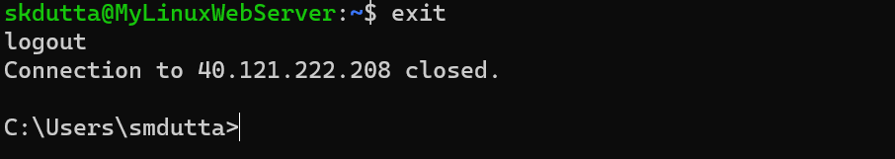

**Step-13 :** **Deploy HTML, CSS and Image file from local computer to azure for hosting.**

